Model : HL-HC1-A
HOPPING CODE RELAY ADAPTER USER MANUAL
Accessories Introduction:

Key Switch Cap. 6x6mm ; 6x3.5mm

DC Power Plug (* Red + , Black )

Power Cable for Original TX (* Red + , Black )

RS-232 Connector for PC

PCB Diagram:

K1 12V 5V
K2
K3 Time

K4

BATT DEL ADD DC12V
Duplicate Adaptor:

Original TX PCB

Control PCB

STEP 1: To setup the duplicate Adapter

- Take the original PCB out of the case, then attached it onto “Original TX PCB“
** Refer to Picture #1 **

- Select the right caps for the key switches (*6x6mm or 6x3.5mm), then plug onto K1~K4 socket of original TX PCB.
** Refer to Picture #2

- Confirm the power voltage of original transmitter is 12V or 3V~6V? Connect the power cable on to battery clips of original transmitter as showed below.
(PS: Pay attention on the direction: Red + , Black --)
** Refer to Picture #3 **

- Put on the cover and put on the screws.
** Refer to Picture #4 & #5 **

- Supply the power with DC12V
** Refer to Picture #6 **

Remark:
- If the push switch of original transmitter is not 6x6mm or 6x3.5mm, you will need to cut the switch then connect the cable by solder. ** Refer to Picture #7 **
- TIME jumper is purpose for transmission time of original transmitter. Jumper ON means 1.5 seconds ; Jumper OPEN means 0.8 seconds.

STEP 2: Programming / Duplicating

After DC12V has been well connected, green LED blinking briefly. Press [DEL] and [ADD] buttons together until red LED goes off after few seconds. This is to secure the memory of this machine has fully cleared.

To duplicate Transmitters:
Press [ ADD ] button of this machine, green LED blinks twice then steady ON Release [ADD] button then press any button of the new transmitter you selected. The red LED blinks once then goes off. It means this new transmitter has been duplicated. Repeat this step to duplicate more transmitters and the maximum is 32 pieces.

To delete duplicated Transmitters:
Press [ DEL ] button of this transceiver machine, red LED blinks twice then lights ON, push any button of duplicated transmitter. The green LED blinks once then goes off. This duplicated transmitter will be deleted.

REMARKS:
- This deleted transmitter can be used as a new transmitter to work on the other receivers.
- If the operating time exceeded 10 seconds during programming mode, system will reset to [stand-by] state and the GREEN LED blinking briefly again.
- During [stand-by] state, you may check if those duplicated transmitters work properly by pressing any button. If the LED of original TX PCB lights ON, it means this duplicated transmitter is ok.

STEP 3: To install this Duplicate Adapter:

To install on a car:
Take the 12V power from battery by wires, Pay attention on the + and – direction. Connect the power wires of battery to the DC12V power connector of this adapter.

To install on a garage:
Place this adapter 3 meters away or above from the original Receiver kit. And supply it with DC12V.

REMARKS:
- The transmission range of this system is 50 meters at sight
- Don not apply this transceiver kit onto any metal surface or enclose it with metal box.
- While you apply this duplicate adapter to your garage or gate, Please be sure to keep it away from your original receiver at least for 3 meters.
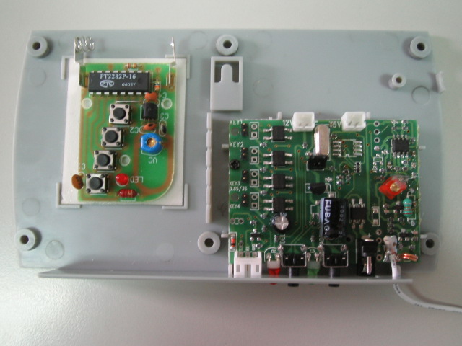
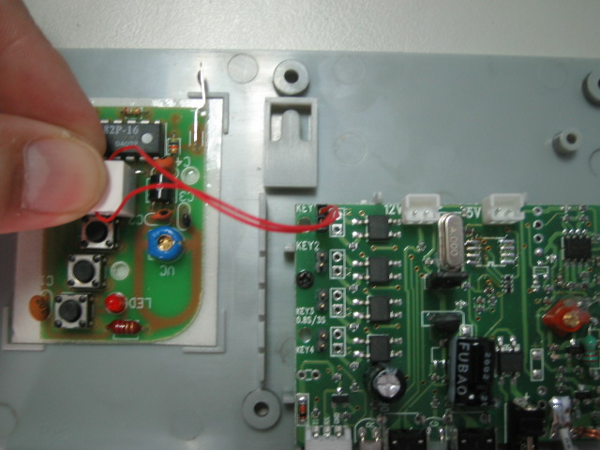

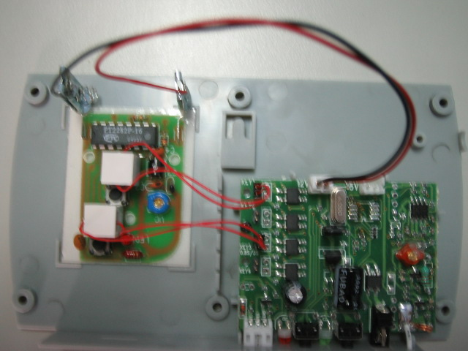

Picture #1 Picture #2 Picture #3

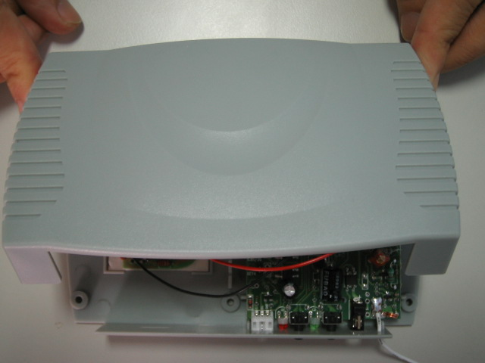
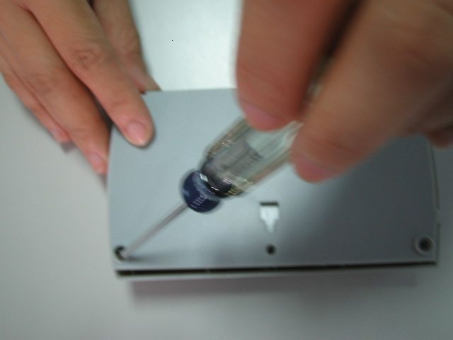
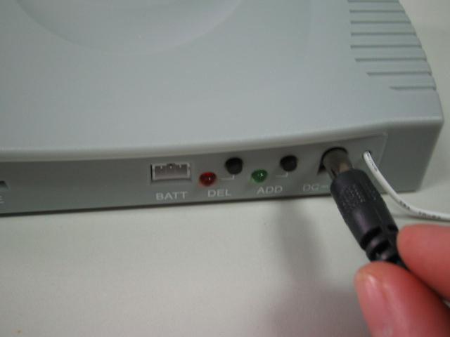

Picture #4 Picture #5 Picture #6

Picture #7 The connection of switch cap to original PCB tact-switch by soldering.

