HI-LEVEL TECHNOLOGY CORP.

6F., No. 8, Lane 114, Hoping Rd., Lu-Chou City, Taipei Hsien, Taiwan, R.O.C.

E-Mail: hilevel@hilevel.com.tw
Homepage: www.hilevel.com.tw
TEL: 886-2-8282-2040 FAX: 886-2-8282-1373

SOS Auto-Dialer HL-850
User’s Manual
Features;
- Convenient – Suitable for use at home, especially for the patient, disabled and those elders or women who stay at home alone.
- Simple in use – User simply needs to pull out the loop on transmitter, then the receiver will automatically trigger the built-in & external sirens (if not set at nursing/silent mode) and dial the preset numbers for help.
- Wide application – Can be connected with magnetic switches, PIR sensors and gas/smoke sensors etc. becoming a security or safety system; or be used as a panic alarm or nursing caller by the additional button on transmitter.

Specification:
- Power of receiver : Input: AC 110V/220V 60Hz / Output: DC 12V 500mA
- Power of transmitter : 12V Alkaline battery
- Backup Battery : DC 9V (approx. 7 hours of use)
- Distance : Approx. 30 meters of straight line
- Radio frequency : 433.92Mhz
- Sound level of built-in siren : 90dB

Notes:
      - Do not install the HL-850 under direct sunlight, high temperature, or high humidity.
      - To get the longest receiving distance, the receiver must not be installed on the electrical
appliances or any metal surface.

The telephone office line (out-line) have to connect with our HL-850 firstly then just

connect with extension telephones. Otherwise, the HL-850 can’t dial out for the emergency help if the extension telephones are using.

If the telephone is selectable for “TONE” or “PULSE” dialing, switch it to the “TONE”

position.
      - The HL-850 is equipped with a built-in backup battery for use during electricity blackout (approx. 7 hours in standby). For initial use, allow minimum 12 hours for battery to be fully charged.
      - User may connect an external siren to call for help from neighbors.

Parts Description & Installation Diagram:

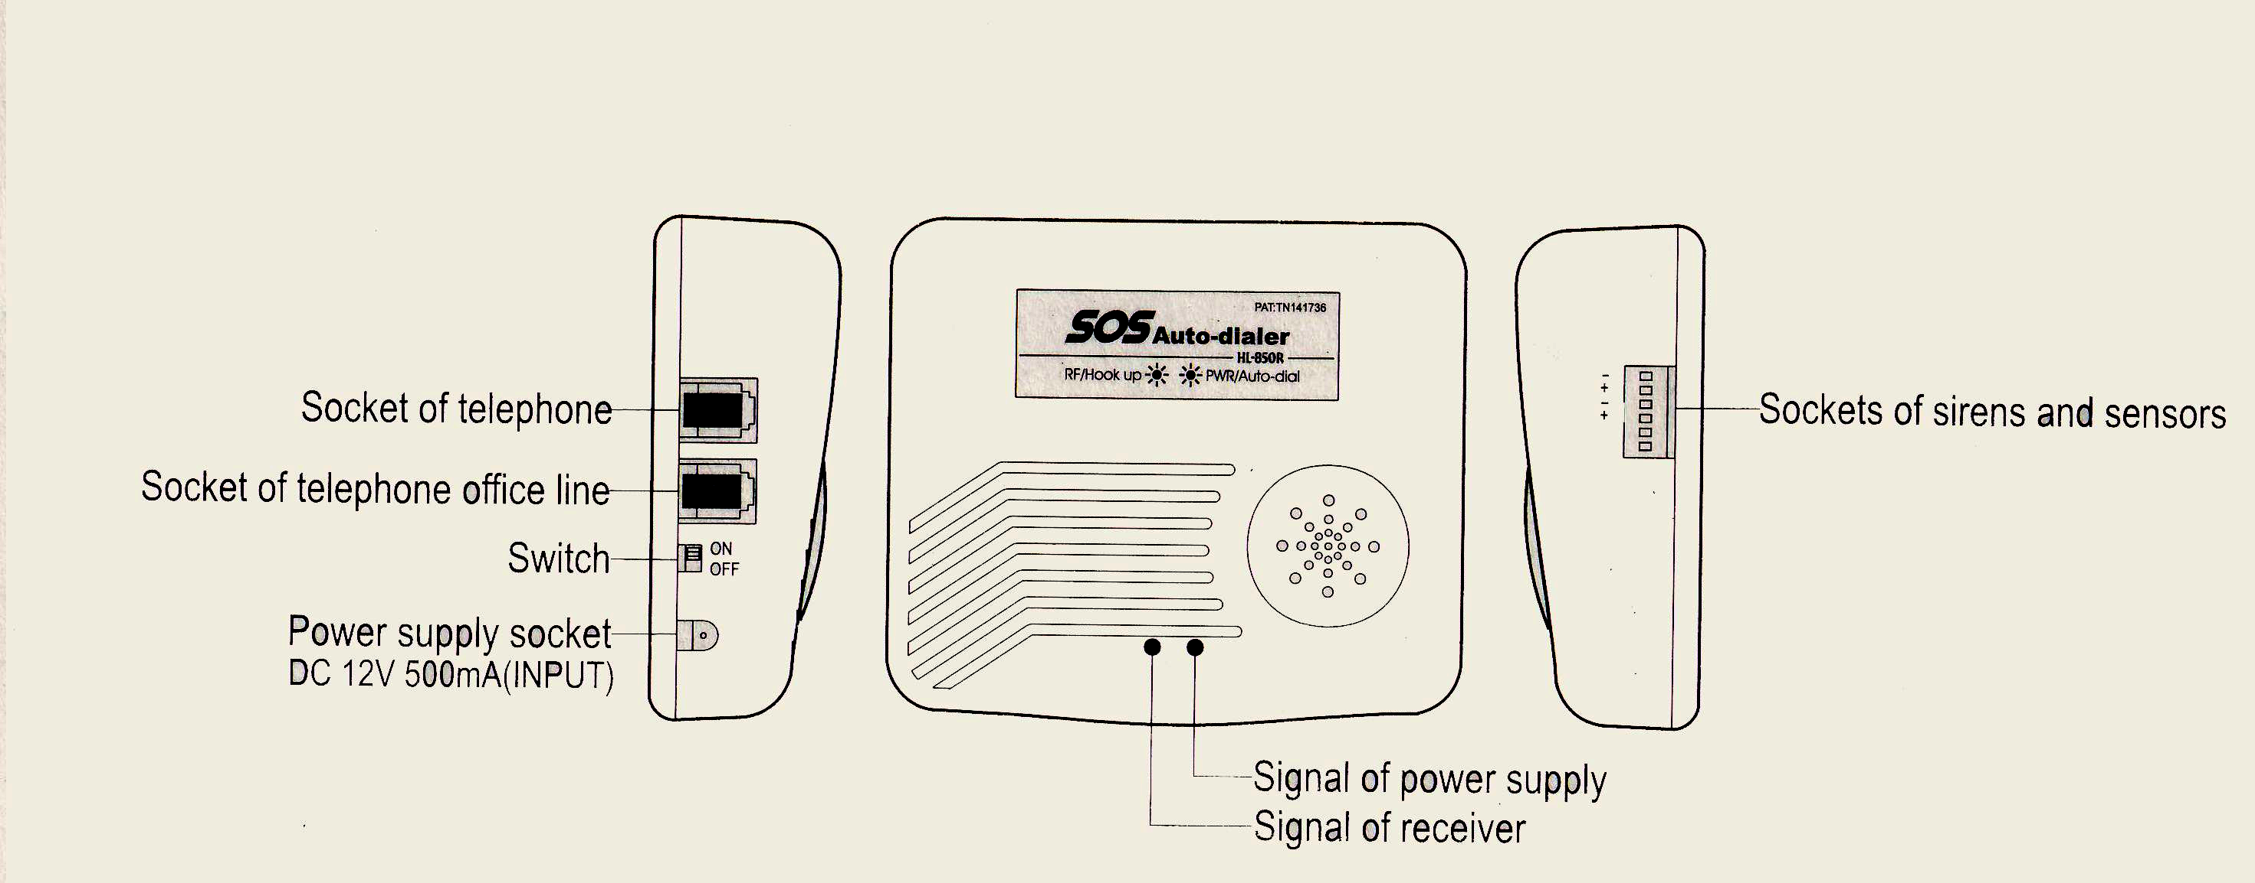

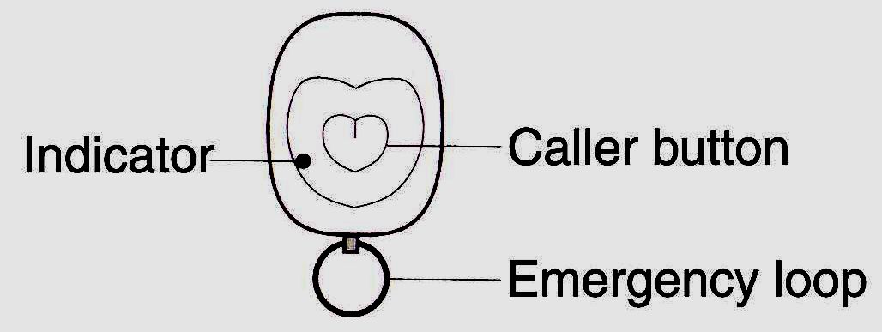

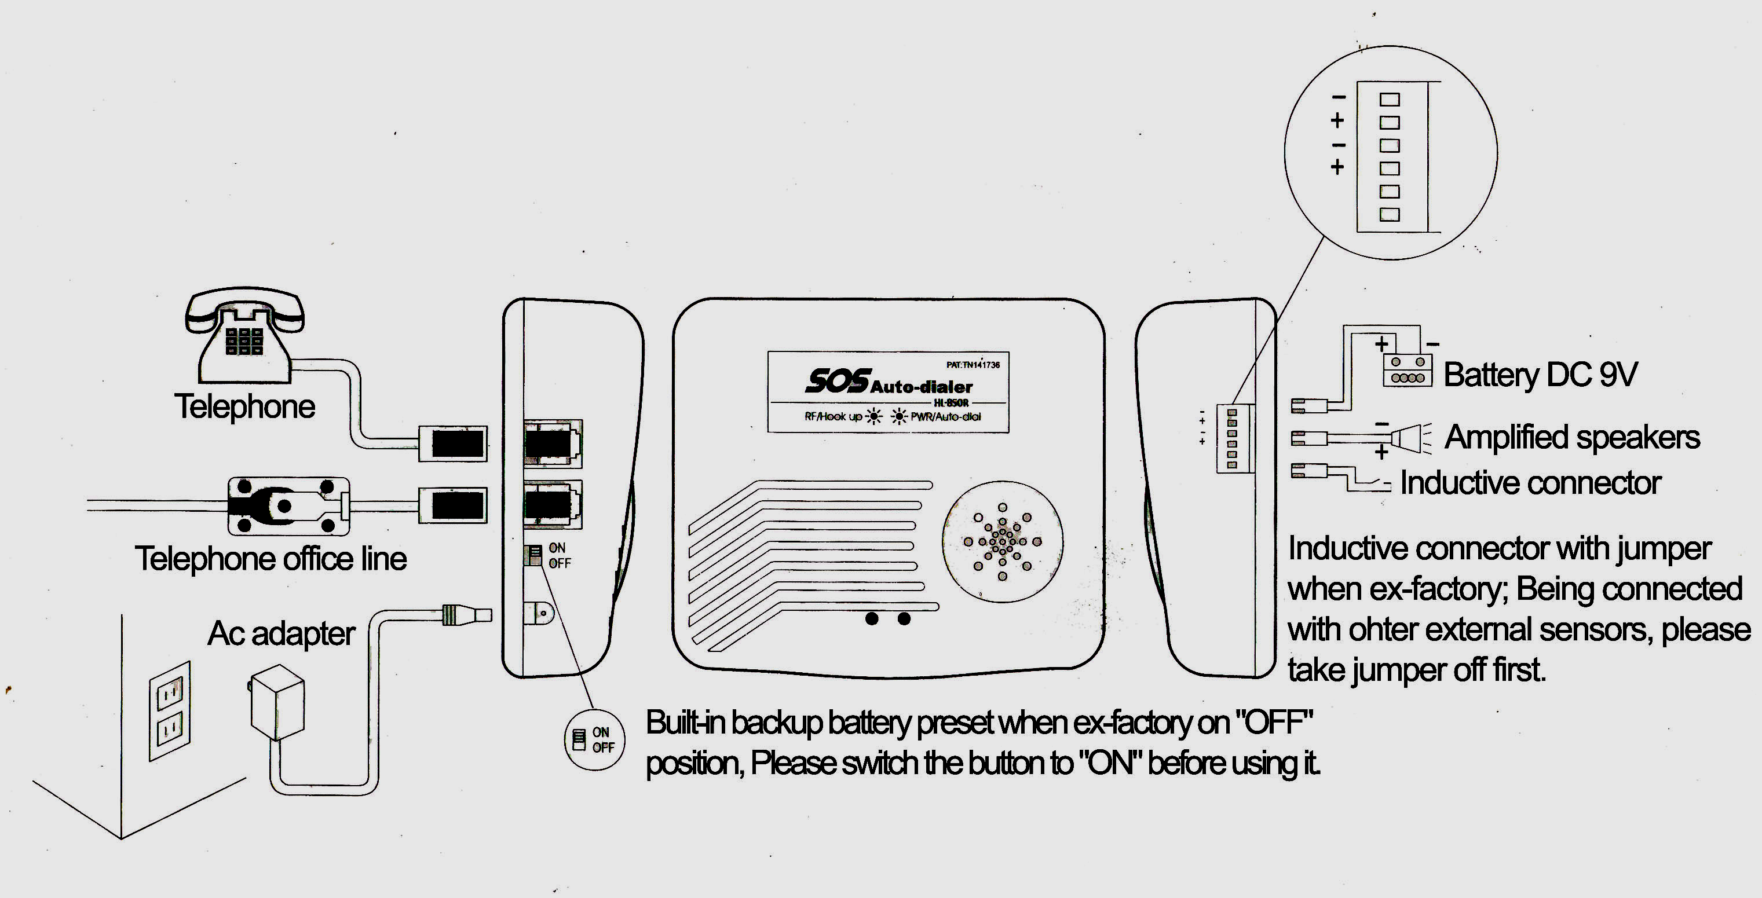

Settings and recording of message:
After installation, lift the phone and set as follows. Hang up the phone when setting finished.
Operation | Description
Dial [＊11] + [Phone No. ] + [＊] | Set-up of 1st auto-dialing number
Dial [＊12] + [Phone No. ] + [＊] | Set-up of 2nd auto-dialing number
Dial [＊13] + [Phone No. ] + [＊] | Set-up of 3rd auto-dialing number
Dial [＊14] + [Phone No. ] + [＊] | Set-up of 4th auto-dialing number
Dial [＊15] + [Phone No. ] + [＊] | Set-up of auto-dialing to a pager
Dial [＊16] + [Number to be shown on the pager called above] + [＊] | Set-up of leaving phone number on the pager being called
Dial [＊21＊] “Beep” sound Start Recording | Recording message (max. 16 seconds)
Dial [＊22＊] Play recorded message | Listening recorded message
Dial [＊25N＊] (N: 1 ~ 9) | Set-up of waiting time before message playing
Dial [＊26N＊] (N: 1 ~ 3) | Set-up of message playing of times
Dial [＊241] + [＊] | Switch ON detection of external sensors
Dial [＊242] + [＊] | Switch OFF detection of external sensors (original setting when ex-factory)
Dial [＊231] + [＊] | Set at “Panic” mode  (original setting when ex-factory)
Dial [＊232] + [＊] | Set at “Nursing/silent” mode
Dial [＊11＊] | Deactivating 1st phone No. (For the others deactivating, dial [＊12＊] [＊13＊] [＊14＊])
Example:

A. Set-up of phone numbers:
1. Set up the 1st phone N. (ex. 12345678)
Pick up phone Dial [＊11] + [12345678] + [＊] Hang up phone
2. If extension number (ex. 123) is required, set as follows.
Dial [＊11] + [12345678] + [#….] + [123] + [＊] (finish)
Note: Each “#” gives 3-second waiting time for dialing, maximum of 5 “#” can be set to give 15-second waiting time for dialing.
B. Set-up of pager number:
1. Set up the pager number (ex. 0123456789)
Pick up phone Dial [＊15] + [0123456789] + [＊] Hang up phone
2. Set up the number to be shown on pager called above (ex. 87654321)
Dial [＊16] + [87654321] + [＊] (finish)
On the above example, the called pager will display “87654321---911 & 87654321---505”.
The numbers “911” & “505” are preset in factory to indicate this is an emergent call.
C. 1. Set-up the waiting time before message playing:
(It can be set 1~9 digits; 1=2-second, 2=4-second, 3=6-second … etc.; default: 2=4-second)
Pick up phone Dial [＊252＊] Hang up phone
On the above example, the record message will be played after the dialing gets through 4-second later.
2. Set-up message playing of times:
Pick up phone Dial [＊263＊] Hang up phone
On the above example, the record message will be played 3 times for each dialing. (It can be set 1~3 times, default: 2 times)
Operation:
A. To call for help in emergency:
Simply pull out the transmitter loop, then the receiver will trigger the sirens(preset＊231＊) and automatically dial the preset numbers for help. The dialing process is as follow.
1. Dial the preset 4 numbers in sequence.
2. Re-dial these 4 numbers again.
3. Dial the preset pager number once.
Note:
a. If siren sound is not required, set the system in nursing/silent mode (preset＊232＊, refer section B-2-b below). Then the receiver will dial silently.
b. To pull the loop of transmitter in any condition, it must call out immediately.
c. To deactivate, replace the transmitter loop and press the transmitter button for one second. Then the receiver will get beep sound about 2 seconds and stop the dialing immediately.
d. Once the dialing gets through, the recorded message will be played and ended with 5
beep sounds. If anyone who receives the call presses the “#” button on his phone before end of 5 beep sounds, the playing will be stopped immediately and this number will not be re-dialed again in the step 2 above.
B. To function as a security/safety system: (Default:＊242＊)
1. If the receiver is switched ON (by dialing＊241＊) for detection of the external sensors
connected, the transmitter button will work as ON/OFF control switch.
a. To activate the security/safety system: Press transmitter button once. One audible beep will be generated to confirm that the system is armed after 15 seconds.
Note: If any sensor is in open-circuit condition, the beep sound will last for one second and system will not be armed.
b. When the system is armed, any break-in (causing open circuit to sensor) or telephone line cut off will be detected by the receiver, which will trigger the siren (unless set at nursing/silent mode(＊232＊)) and automatically dial for help (same as above section A).
c. To deactivate the system: Press transmitter button once. Two audible beep sounds will be generated to confirm disarming.
Note: If preset [＊241＊] in setting, the condition will be executed prior than other setting.
2. If the receiver is switched OFF (by dialing＊242＊), the transmitter button can still be used as a panic alarm or nursing switch.
a. Panic alarm :siren sounds for 20 seconds to deter the intruder
By setting the system in “panic” mode (dialing＊231＊), press of the transmitter button
will activate the siren to sound for 20 seconds. To deactivate, it should wait for 7 seconds later then press the button to stop the siren sound.
b. Nursing switch : siren sounds for 2 seconds to ask for assistance
By setting the system in “nursing/silent” mode (dialing＊232＊), press of the transmitter button will activate the siren to sound for 2 seconds.
Note: At this mode the internal & external sirens will not sound in emergency calling, or when intruded if used as security/safety system.

HL-850-DS(wireless magnetic switch) of operation:
  - Place the device at door or window.
  - Turn the switch on “1” position when using, the Red LED lights on then goes out.
  - Once the device is triggered, the Red LED will lights on 1 second for transmission.
  - Power test: Press button the Red LED blinking : power enough
the Green LED lighting : powerless; change battery

HL-850-DS

Contents:
      - HL-850 SOS receiver (auto-dialer) x 1
      - Emergency transmitter x 1
      - AC Adapter x 1
      - Telephone cable x 1
      - Manual x 1
      - External cable x 2

Remarks:

HL-850-DS (wireless magnetic switch) is option, maximum 4 pieces for one set of HL-850.

