301H-98 DUAL-CHANNELS DUPLICATOR

INSTRUCTIONS

HOW TO DUPLICATE THE CODE:
- By pressing and holding the button of 301H-98 first then pressing and holding the button of original transmitters, their position is such as sketch 1. When the code well learn from the original TX, the LED bulb of the 301H-98 blinking → solid on → going off.
- The buttons pressing must be button 1 vis-à-vis button 1, button 2 vis-à-vis button 2, … until all buttons pressed.
- If the code learning fail, the LED bulb of the 301H-98 keep blinking when pressing the button or does not go off. Please change the holding position of both transmitters to “side by side”, or “back to back” or “overlapping both TX” or any position better than head to head.

HOW TO DUPLICATE THE FREQUENCY:
- Check the frequency range of the original transmitter, by putting the original transmitter at TX zone of the digital frequency counter and press the button of original TX. The digital screen of the frequency counter will display the frequency of the original TX in figures.
- Tune the frequency of the 301H-98 as same as the frequency of the original TX via the digital frequency counter.

NOTES:
1. Frequency Range from 260Mhz to 460Mhz, related condition of two selections below:
Frequency 1(trimmer 1) | Push the switch at up position | LED flashing in Red color
Frequency 2(trimmer 2) | Push the switch at down position | LED flashing in Green color
2. Code erasing: Pressing and holding button 1,2,3 and 4 at the same time, LED blinking 3 times and goes off. Release buttons, the code is erased
3. Do not operate all the procedures at the desk covered with metal plate.
4. When the frequency 1 & 2 have duplicated to finish from the original TX, please repeat to check and correct the frequency 1 & 2 over twice.
SKETCH

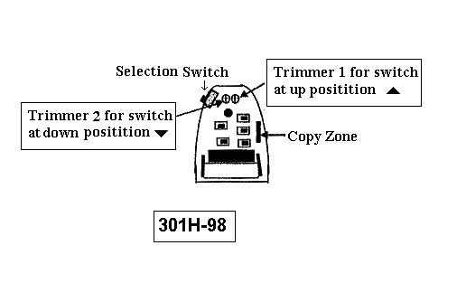

Best Position of Duplication
