301H-91 DUPLICATION TRANSMITTER

INSTRUCTIONS

HOW TO DUPLICATE THE CODE:
- By pressing and holding the button of 301H-91 first then pressing and holding the button of original transmitters, their position is such as sketch 1. When the code well learn from the original TX, the LED bulb of the 301H-91 blinking → solid on → going off.
- The buttons pressing must be button 1 vis-à-vis button 1, button 2 vis-à-vis button 2, … until all buttons pressed.
- If the code learning fail, the LED bulb of the 301H-91 keep blinking when pressing the button or does not go off. Please change the holding position of both transmitters to “side by side”, or “back to back” or “overlapping both TX” or any position better than head to head.

HOW TO DUPLICATE THE FREQUENCY:
- Check the frequency range of the original transmitter, by putting the original transmitter at TX zone of the digital frequency counter and press the button of original TX. The digital screen of the frequency counter will display the frequency of the original TX in figures.
- Tune the frequency of the 301H-91 as same as the frequency of the original TX via the digital frequency counter. (Code learning has to complete first)
The corresponding frequency range with the jumper position as refer following:
Frequency Range | 250 – 280  MHz | 270 – 320 MHz | 280 – 350 MHz | 310 – 490 MHz
Jumper position |  |  |  | 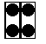
NOTES:

1. Code erasing: Pressing and holding 4 buttons or 5 buttons at the same time, LED blinking 3 times and goes off. Release buttons, the code is erased
2. Code learning can only be effect when the 301H-91 is BLANK—LED light flashing.
3. Do not operate all the procedures at the desk covered with metal plate.

Sketch 1.

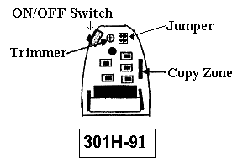
The best position of duplication we proposed:
