301H-5HS Code / Frequency Simultaneously Learning

Frequency Range: LC: 250-450Mhz; SAW: 433.92Mhz
[1]. Transmission
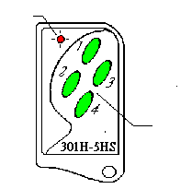Pressing any one channel button, LED lights on solid。

LED
[2]. To activate Code / Frequency Learning Mode
Press and hold buttons 1+2 together, count LED flashing
Channels
button
- LED Flashes once then release – Transmission mode
- LED Flashes twice then release – LC Code Learning mode
- LED Flashes thrice then release –SAW Code Learning mode
[3]. To Proceed Code / Frequency Learning – Code Learning mode
As sketch (1) ; Hold original (Old) transmitter at Left hand side and
301H-5HS at Right hand side.
a). Keep 15cm distance between Old TX (transmitter) and 301H-5HS
b). Pressing button 1. of Old TX and 301H-5HS together at the same time
c). 301H-5HS flashes twice and goes off
d). Now slowly move the Old TX to right hand side and stop when 301H-5HS LED is
lighting on solid
e). 3 seconds after, LED goes off, code/frequency learning is complete for button 1.
f). Button 2 or 3… please proceed the steps as a) …e)
Remark :
[A]. If code/frequency learning of 301H-5HS is not successful from the above proceeding, please change the position of Old TX as sketch (2) and starting again from steps a)…. e) .
[B]. Step b.) – If LED of 301H-5HS lights ON, 301H-5HS is not under Code/Frequency Learning mode, please proceed step [2] again.
Sketch (1).
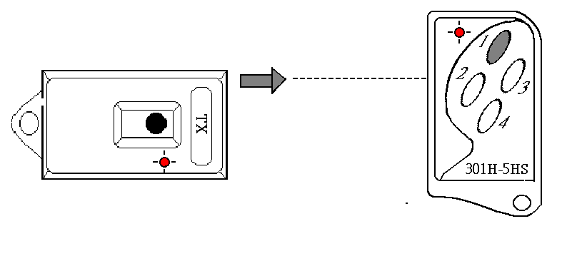
Sketch (2).
Original
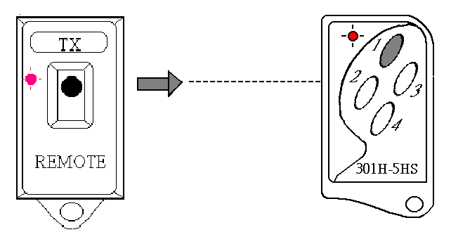
Original
15cm
15cm
Left hand side
moving to
Right hand side (Still)
Left hand side moving to
Right hand side (Still)

