301H-2H Code / Frequency Simultaneously Learning
[1]. Transmission Frequency Range: 250-450Mhz
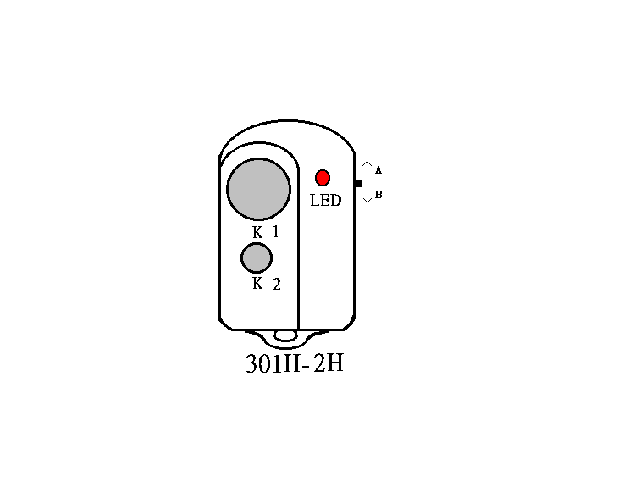
Pressing any one channel button, LED lights on solid。
[2]. To activate Code / Frequency Learning Mode
Press and hold buttons 1+2 together, count LED flashing
- LED Flashes once then release – Transmission mode
- LED Flashes twice then release – Learning mode

[3]. To Proceed Code / Frequency Learning --Code Learning mode
As sketch (1) ; Hold original (Old) transmitter at Left hand side and 301H-2H at Right hand side.
a). Keep 15cm distance between Old TX (transmitter) and 301H-2H
b). Pressing button 1. of Old TX and 301H-2H together at the same time.
c). 301H-2H flashes twice and goes off,
d). Now slowly move the Old TX to right hand side and stop moving when the LED of 301H-2H is on solid.
e). Still pressing & holding 3 seconds after the LED of 301H-2H goes off then release your hand.
Code/frequency learning is complete for button 1.
f ). Button 2 or 3… please proceed the steps as a) …e)
Remark :
[A]. If code/frequency learning of 301H-2H is not successful from the above proceeding, please change the position of Old TX as sketch (2) and starting again from steps a)…e) .
[B]. Step b.) – If LED of 301H-2H lights ON, 301H-2H is not under Code/Frequency Learning mode, please proceed
step [2] again.
[C]. A/B section switch: Turn switch up at A. section – 2 channels are able to learn 2 different codes & frequencies
Turn switch down at B section–2 channels are able to learn 2 different codes & frequencies
[D]. It will skip out the ‘Learning Mode’ if pressing any buttons over 4 times. Please renew to enter the
‘learning mode’ and do the procedures again for completing duplication. 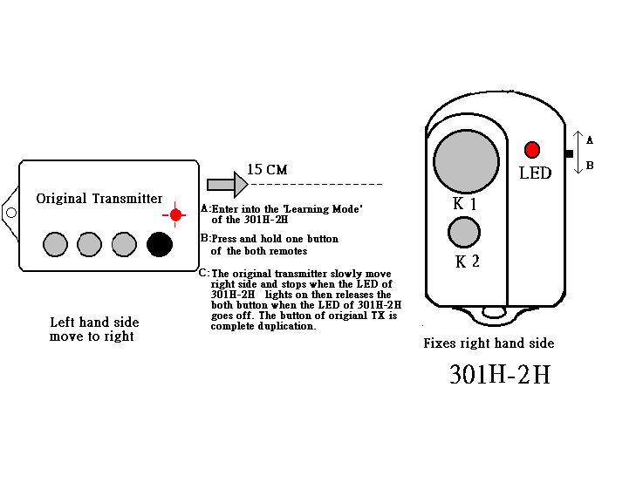
Sketch (1).
Sketch (2).
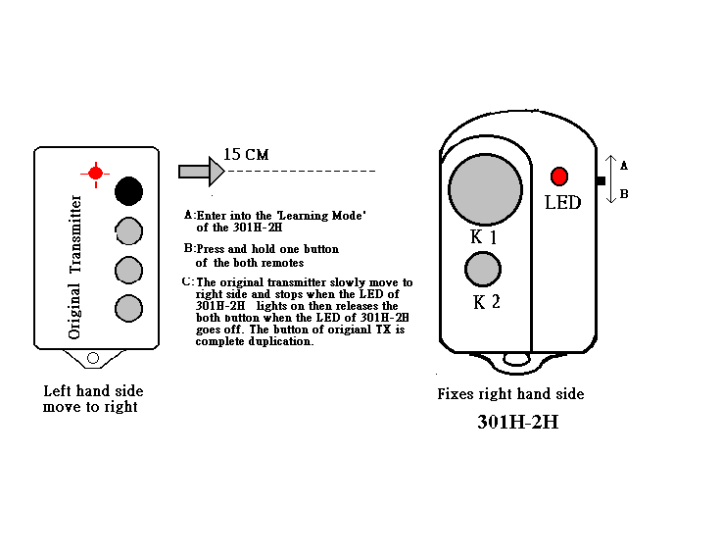

` SIMPLY OPERATION INSTRUCTION
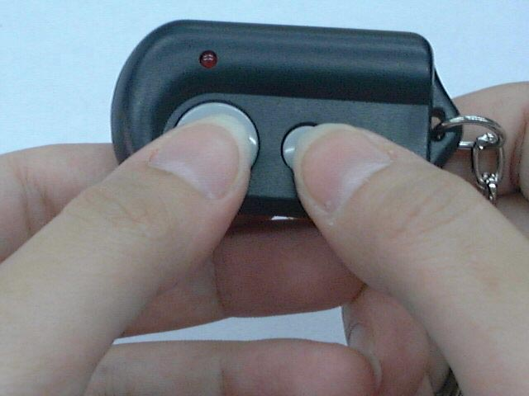
Press and hold buttons 1+2 together, count LED flashing
◆LED Flashes once then release – Transmission mode
◆LED Flashes twice then release – Learning mode

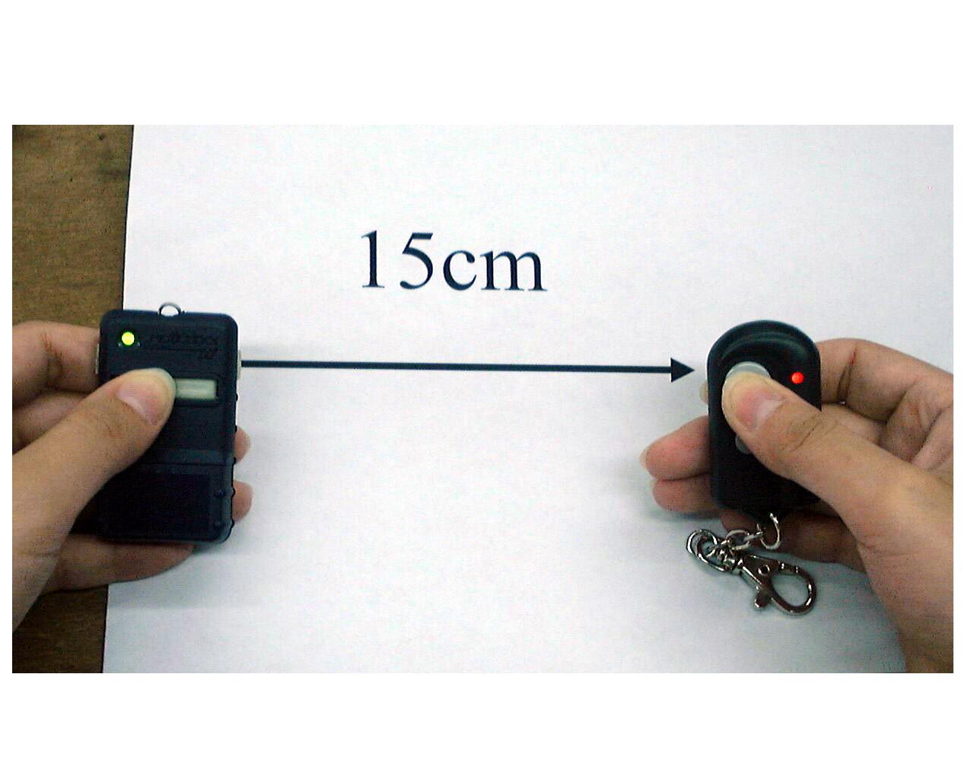
a). Keep 15cm distance between Old TX (transmitter) and 301H-2H
b). Pressing button 1. of Old TX and 301H-2H together at the same time.
c). 301H-2H flashes twice and goes off,

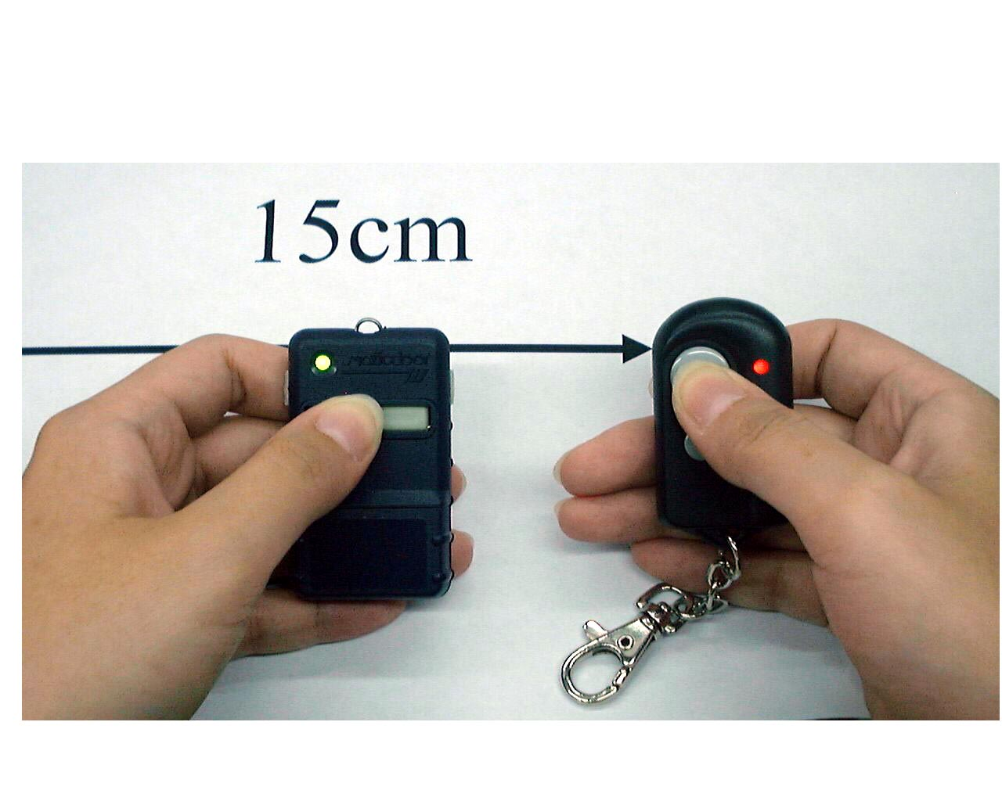
d). Now slowly move the Old TX to right hand side and stop moving when the LED of 301H-2H is on solid.
e). Still pressing & holding 3 seconds after the LED of 301H-2H goes off then release your hand.
Code/frequency learning is complete for button 1.
f ). Button 2 or 3… please proceed the steps as a) …e)

