301H-1A INSTRUCTION (SAW433.92Mhz)

SKETCH 1.
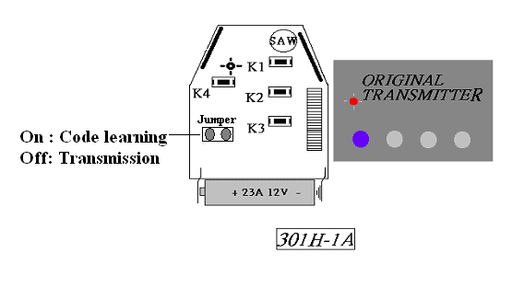
☆Mode Selection:

A. When the jumper ON enter Code Learning mode (LED lighting)
B. When the jumper OFF enter Transmission mode (LED blinking)

<A> Codes Learning Mode:
Such as SKETCH 1, place both TX closed, firstly press and hold any buttons of 301H-1A then press and hold any buttons of the original transmitter; the code of this button has been copied completely when the LED of 301H-1A is blinking →lighting → going off . According to this step copying other buttons.
(If can’t completely copy via the position of Sketch 1, please turn the position of the original TX to perpendicular (90°). Then repeat procedure.)

<B>備註
1. Don’t operate all the procedures on the metal table.

